

**МІНІСТЕРСТВО ОСВІТИ І НАУКИ УКРАЇНИ**

**ННК «ІПСА» НТУУ «КПІ ІМ. ІГОРЯ СІКОРСЬКОГО» КАФЕДРА ММСА**

**Практична робота № 3**

**З курсу:** «**Комп’ютерні мережі**»

**Виконала: Студент ІIІ курсу**

**Групи КА-73 Ващенко А.А.**

**Прийняв: Кухарєв С.О.**

**Київ 2020**

# 3.2.1

Frame 4: 74 bytes on wire (592 bits), 74 bytes captured (592 bits) on interface \Device\NPF_{DD4C1491-1450-4267-96D7-9C982304A0FB},

|  |  |  |  |  |
| --- | --- | --- | --- | --- |
| No. | Time | Source | Destination | Protocol Length Info |
|  | 4 1.802595 | 192.168.0.102 | 192.168.0.1 | DNS 74 Standard query 0x16d4 A [www.google.com](http://www.google.com/) |

id 0

Ethernet II, Src: IntelCor_f3:47:88 (98:54:1b:f3:47:88), Dst: Tp-LinkT_2d:ab:60 (64:66:b3:2d:ab:60) Internet Protocol Version 4, Src: 192.168.0.102, Dst: 192.168.0.1

User Datagram Protocol, Src Port: 51634, Dst Port: 53 Domain Name System (query)

Transaction ID: 0x16d4 Flags: 0x0100 Standard query Questions: 1

Answer RRs: 0

Authority RRs: 0

Additional RRs: 0 Queries [Response In: 5]

No. Time Source Destination Protocol Length Info

5 1.806988 192.168.0.1 192.168.0.102 DNS 338 Standard query response 0x16d4 A [www.google.com](http://www.google.com/) A 216.58.209.4 NS ns4.google.com NS ns3.google.com NS ns1.google.com NS ns2.google.com A 216.239.34.10 AAAA 2001:4860:4802:34::a A 216.239.38.10 AAAA 2001:4860:4802:38::a A 216.239.32.10 AAAA 2001:4860:4802:32::a A 216.239.36.10 AAAA 2001:4860:4802:36::a

Frame 5: 338 bytes on wire (2704 bits), 338 bytes captured (2704 bits) on interface

\Device\NPF_{DD4C1491-1450-4267-96D7-9C982304A0FB}, id 0

Ethernet II, Src: Tp-LinkT_2d:ab:60 (64:66:b3:2d:ab:60), Dst: IntelCor_f3:47:88 (98:54:1b:f3:47:88) Internet Protocol Version 4, Src: 192.168.0.1, Dst: 192.168.0.102

User Datagram Protocol, Src Port: 53, Dst Port: 51634 Domain Name System (response)

Transaction ID: 0x16d4

Flags: 0x8180 Standard query response, No error Questions: 1

Answer RRs: 1

Authority RRs: 4

Additional RRs: 8 Queries

Answers

[www.google.com:](http://www.google.com/) type A, class IN, addr 216.58.209.4 Authoritative nameservers

google.com: type NS, class IN, ns ns4.google.com google.com: type NS, class IN, ns ns3.google.com google.com: type NS, class IN, ns ns1.google.com google.com: type NS, class IN, ns ns2.google.com

Additional records

ns2.google.com: type A, class IN, addr 216.239.34.10 ns2.google.com: type AAAA, class IN, addr 2001:4860:4802:34::a ns4.google.com: type A, class IN, addr 216.239.38.10 ns4.google.com: type AAAA, class IN, addr 2001:4860:4802:38::a ns1.google.com: type A, class IN, addr 216.239.32.10 ns1.google.com: type AAAA, class IN, addr 2001:4860:4802:32::a ns3.google.com: type A, class IN, addr 216.239.36.10 ns3.google.com: type AAAA, class IN, addr 2001:4860:4802:36::a

[Request In: 4]

[Time: 0.004393000 seconds]

No. Time Source Destination Protocol Length Info

16 2.930274 192.168.0.102 192.168.0.1 DNS 72 Standard query 0x7056 A [www.ietf.org](http://www.ietf.org/)

Frame 16: 72 bytes on wire (576 bits), 72 bytes captured (576 bits) on interface \Device\NPF_{DD4C1491-1450-4267-96D7-9C982304A0FB},

id 0

Ethernet II, Src: IntelCor_f3:47:88 (98:54:1b:f3:47:88), Dst: Tp-LinkT_2d:ab:60 (64:66:b3:2d:ab:60) Internet Protocol Version 4, Src: 192.168.0.102, Dst: 192.168.0.1

User Datagram Protocol, Src Port: 61717, Dst Port: 53 Domain Name System (query)

Transaction ID: 0x7056 Flags: 0x0100 Standard query Questions: 1

Answer RRs: 0

Authority RRs: 0

Additional RRs: 0 Queries [Response In: 17]

No. Time Source Destination Protocol Length Info

17 2.949203 192.168.0.1 192.168.0.102 DNS 546 Standard query response 0x7056 A [www.ietf.org](http://www.ietf.org/) CNAME [www.ietf.org.cdn.cloudflare.net](http://www.ietf.org.cdn.cloudflare.net/) A 104.20.0.85 A 104.20.1.85 NS f.gtld-servers.net NS e.gtld-servers.net NS g.gtld-servers.net NS c.gtld-servers.net NS h.gtld-servers.net NS b.gtld-servers.net NS i.gtld-servers.net NS l.gtld-servers.net NS d.gtld-servers.net NS a.gtld-servers.net NS m.gtld-servers.net NS k.gtld-servers.net NS j.gtld-servers.net A 192.41.162.30 AAAA 2001:500:d937::30 A 192.31.80.30 AAAA 2001:500:856e::30 A 192.26.92.30 AAAA 2001:503:83eb::30 A 192.35.51.30 AAAA 2001:503:d414::30

Frame 17: 546 bytes on wire (4368 bits), 546 bytes captured (4368 bits) on interface

\Device\NPF_{DD4C1491-1450-4267-96D7-9C982304A0FB}, id 0

Ethernet II, Src: Tp-LinkT_2d:ab:60 (64:66:b3:2d:ab:60), Dst: IntelCor_f3:47:88 (98:54:1b:f3:47:88) Internet Protocol Version 4, Src: 192.168.0.1, Dst: 192.168.0.102

User Datagram Protocol, Src Port: 53, Dst Port: 61717 Domain Name System (response)

Transaction ID: 0x7056

Flags: 0x8180 Standard query response, No error Questions: 1

Answer RRs: 3

Authority RRs: 13

Additional RRs: 8

Queries Answers

[www.ietf.org:](http://www.ietf.org/) type CNAME, class IN, cname [www.ietf.org.cdn.cloudflare.net](http://www.ietf.org.cdn.cloudflare.net/) [www.ietf.org.cdn.cloudflare.net:](http://www.ietf.org.cdn.cloudflare.net/) type A, class IN, addr 104.20.0.85 [www.ietf.org.cdn.cloudflare.net:](http://www.ietf.org.cdn.cloudflare.net/) type A, class IN, addr 104.20.1.85

Authoritative nameservers

net: type NS, class IN, ns f.gtld-servers.net net: type NS, class IN, ns e.gtld-servers.net net: type NS, class IN, ns g.gtld-servers.net net: type NS, class IN, ns c.gtld-servers.net net: type NS, class IN, ns h.gtld-servers.net net: type NS, class IN, ns b.gtld-servers.net net: type NS, class IN, ns i.gtld-servers.net net: type NS, class IN, ns l.gtld-servers.net net: type NS, class IN, ns d.gtld-servers.net net: type NS, class IN, ns a.gtld-servers.net net: type NS, class IN, ns m.gtld-servers.net net: type NS, class IN, ns k.gtld-servers.net net: type NS, class IN, ns j.gtld-servers.net

Additional records

l.gtld-servers.net: type A, class IN, addr 192.41.162.30 l.gtld-servers.net: type AAAA, class IN, addr 2001:500:d937::30 d.gtld-servers.net: type A, class IN, addr 192.31.80.30

d.gtld-servers.net: type AAAA, class IN, addr 2001:500:856e::30 c.gtld-servers.net: type A, class IN, addr 192.26.92.30

c.gtld-servers.net: type AAAA, class IN, addr 2001:503:83eb::30 f.gtld-servers.net: type A, class IN, addr 192.35.51.30

f.gtld-servers.net: type AAAA, class IN, addr 2001:503:d414::30 [Request In: 16]

[Time: 0.018929000 seconds]

No. Time Source Destination Protocol Length Info

30 3.420200 192.168.0.102 192.168.0.1 DNS 91 Standard query 0x7de8

A webadvisorc.rest.gti.mcafee.com

Frame 30: 91 bytes on wire (728 bits), 91 bytes captured (728 bits) on interface \Device\NPF_{DD4C1491-1450-4267-96D7-9C982304A0FB},

id 0

Ethernet II, Src: IntelCor_f3:47:88 (98:54:1b:f3:47:88), Dst: Tp-LinkT_2d:ab:60 (64:66:b3:2d:ab:60) Internet Protocol Version 4, Src: 192.168.0.102, Dst: 192.168.0.1

User Datagram Protocol, Src Port: 60820, Dst Port: 53 Domain Name System (query)

Transaction ID: 0x7de8 Flags: 0x0100 Standard query Questions: 1

Answer RRs: 0

Authority RRs: 0

Additional RRs: 0 Queries [Response In: 33]

No. Time Source Destination Protocol Length Info

33 3.423819 192.168.0.1 192.168.0.102 DNS 547 Standard query response 0x7de8 A

webadvisorc.rest.gti.mcafee.com CNAME rest.gti.mcafee.akadns.net A 161.69.169.70 A 161.69.169.72 A 161.69.169.73 A 161.69.169.71 NS e.root-servers.net NS h.root-servers.net NS j.root-servers.net NS k.root-servers.net NS d.root-servers.net NS l.root-servers.net NS g.root-servers.net NS a.root-servers.net NS i.root-servers.net NS c.root-servers.net NS b.root-servers.net NS m.root-servers.net NS f.root-servers.net A 198.41.0.4 A 199.9.14.201 A 192.33.4.12 A 199.7.91.13 A 192.203.230.10 A 192.5.5.241 A 192.112.36.4 A

198.97.190.53 A 192.36.148.17

Frame 33: 547 bytes on wire (4376 bits), 547 bytes captured (4376 bits) on interface

\Device\NPF_{DD4C1491-1450-4267-96D7-9C982304A0FB}, id 0

Ethernet II, Src: Tp-LinkT_2d:ab:60 (64:66:b3:2d:ab:60), Dst: IntelCor_f3:47:88 (98:54:1b:f3:47:88) Internet Protocol Version 4, Src: 192.168.0.1, Dst: 192.168.0.102

User Datagram Protocol, Src Port: 53, Dst Port: 60820 Domain Name System (response)

Transaction ID: 0x7de8

Flags: 0x8180 Standard query response, No error Questions: 1

Answer RRs: 5

Authority RRs: 13

Additional RRs: 9 Queries

Answers

webadvisorc.rest.gti.mcafee.com: type CNAME, class IN, cname rest.gti.mcafee.akadns.net rest.gti.mcafee.akadns.net: type A, class IN, addr 161.69.169.70 rest.gti.mcafee.akadns.net: type A, class IN, addr 161.69.169.72 rest.gti.mcafee.akadns.net: type A, class IN, addr 161.69.169.73 rest.gti.mcafee.akadns.net: type A, class IN, addr 161.69.169.71

Authoritative nameservers

<Root>: type NS, class IN, ns e.root-servers.net

<Root>: type NS, class IN, ns h.root-servers.net

<Root>: type NS, class IN, ns j.root-servers.net

<Root>: type NS, class IN, ns k.root-servers.net

<Root>: type NS, class IN, ns d.root-servers.net

<Root>: type NS, class IN, ns l.root-servers.net

<Root>: type NS, class IN, ns g.root-servers.net

<Root>: type NS, class IN, ns a.root-servers.net

<Root>: type NS, class IN, ns i.root-servers.net

<Root>: type NS, class IN, ns c.root-servers.net

<Root>: type NS, class IN, ns b.root-servers.net

<Root>: type NS, class IN, ns m.root-servers.net

<Root>: type NS, class IN, ns f.root-servers.net Additional records

a.root-servers.net: type A, class IN, addr 198.41.0.4 b.root-servers.net: type A, class IN, addr 199.9.14.201 c.root-servers.net: type A, class IN, addr 192.33.4.12 d.root-servers.net: type A, class IN, addr 199.7.91.13 e.root-servers.net: type A, class IN, addr 192.203.230.10 f.root-servers.net: type A, class IN, addr 192.5.5.241 g.root-servers.net: type A, class IN, addr 192.112.36.4 h.root-servers.net: type A, class IN, addr 198.97.190.53 i.root-servers.net: type A, class IN, addr 192.36.148.17

[Request In: 30]

[Time: 0.003619000 seconds]

No. Time Source Destination Protocol Length Info

80 3.621467 192.168.0.102 192.168.0.1 DNS 88 Standard query 0xa140

A mip.api.mcafeewebadvisor.com

Frame 80: 88 bytes on wire (704 bits), 88 bytes captured (704 bits) on interface \Device\NPF_{DD4C1491-1450-4267-96D7-9C982304A0FB},

id 0

Ethernet II, Src: IntelCor_f3:47:88 (98:54:1b:f3:47:88), Dst: Tp-LinkT_2d:ab:60 (64:66:b3:2d:ab:60) Internet Protocol Version 4, Src: 192.168.0.102, Dst: 192.168.0.1

User Datagram Protocol, Src Port: 56519, Dst Port: 53 Domain Name System (query)

Transaction ID: 0xa140 Flags: 0x0100 Standard query Questions: 1

Answer RRs: 0

Authority RRs: 0

Additional RRs: 0 Queries [Response In: 89]

No. Time Source Destination Protocol Length Info

89 3.626928 192.168.0.1 192.168.0.102 DNS 519 Standard query response 0xa140 A

mip.api.mcafeewebadvisor.com CNAME WACloudLB-1801077940.us-east-1.elb.amazonaws.com A 34.238.24.46 A 3.223.217.186 A 52.206.61.163

A 52.86.217.36 A 34.231.15.188 A 52.2.157.209 A 34.199.12.246 A 54.81.233.88 NS u1.amazonaws.com NS u2.amazonaws.com NS r2.amazonaws.com NS r1.amazonaws.com A 156.154.64.10 AAAA 2001:502:f3ff::10 A 156.154.65.10 AAAA 2610:a1:1014::10 A 205.251.192.27 AAAA 2600:9000:5300:1b00::1 A 205.251.195.199 AAAA 2600:9000:5303:c700::1

Frame 89: 519 bytes on wire (4152 bits), 519 bytes captured (4152 bits) on interface

\Device\NPF_{DD4C1491-1450-4267-96D7-9C982304A0FB}, id 0

Ethernet II, Src: Tp-LinkT_2d:ab:60 (64:66:b3:2d:ab:60), Dst: IntelCor_f3:47:88 (98:54:1b:f3:47:88) Internet Protocol Version 4, Src: 192.168.0.1, Dst: 192.168.0.102

User Datagram Protocol, Src Port: 53, Dst Port: 56519 Domain Name System (response)

Transaction ID: 0xa140

Flags: 0x8180 Standard query response, No error Questions: 1

Answer RRs: 9

Authority RRs: 4

Additional RRs: 8 Queries

Answers

mip.api.mcafeewebadvisor.com: type CNAME, class IN, cname WACloudLB-1801077940.us-east-1.elb.amazonaws.com WACloudLB-1801077940.us-east-1.elb.amazonaws.com: type A, class IN, addr 34.238.24.46

WACloudLB-1801077940.us-east-1.elb.amazonaws.com: type A, class IN, addr 3.223.217.186 WACloudLB-1801077940.us-east-1.elb.amazonaws.com: type A, class IN, addr 52.206.61.163 WACloudLB-1801077940.us-east-1.elb.amazonaws.com: type A, class IN, addr 52.86.217.36 WACloudLB-1801077940.us-east-1.elb.amazonaws.com: type A, class IN, addr 34.231.15.188 WACloudLB-1801077940.us-east-1.elb.amazonaws.com: type A, class IN, addr 52.2.157.209 WACloudLB-1801077940.us-east-1.elb.amazonaws.com: type A, class IN, addr 34.199.12.246 WACloudLB-1801077940.us-east-1.elb.amazonaws.com: type A, class IN, addr 54.81.233.88

Authoritative nameservers

amazonaws.com: type NS, class IN, ns u1.amazonaws.com amazonaws.com: type NS, class IN, ns u2.amazonaws.com amazonaws.com: type NS, class IN, ns r2.amazonaws.com amazonaws.com: type NS, class IN, ns r1.amazonaws.com

Additional records

u1.amazonaws.com: type A, class IN, addr 156.154.64.10 u1.amazonaws.com: type AAAA, class IN, addr 2001:502:f3ff::10 u2.amazonaws.com: type A, class IN, addr 156.154.65.10 u2.amazonaws.com: type AAAA, class IN, addr 2610:a1:1014::10 r1.amazonaws.com: type A, class IN, addr 205.251.192.27 r1.amazonaws.com: type AAAA, class IN, addr 2600:9000:5300:1b00::1 r2.amazonaws.com: type A, class IN, addr 205.251.195.199 r2.amazonaws.com: type AAAA, class IN, addr 2600:9000:5303:c700::1

[Request In: 80]

[Time: 0.005461000 seconds]

No. Time Source Destination Protocol Length Info

932 5.002927 192.168.0.102 192.168.0.1 DNS 78 Standard query 0x66aa A analytics.ietf.org

Frame 932: 78 bytes on wire (624 bits), 78 bytes captured (624 bits) on interface

\Device\NPF_{DD4C1491-1450-4267-96D7-9C982304A0FB}, id 0

Ethernet II, Src: IntelCor_f3:47:88 (98:54:1b:f3:47:88), Dst: Tp-LinkT_2d:ab:60 (64:66:b3:2d:ab:60) Internet Protocol Version 4, Src: 192.168.0.102, Dst: 192.168.0.1

User Datagram Protocol, Src Port: 49273, Dst Port: 53 Domain Name System (query)

Transaction ID: 0x66aa

Flags: 0x0100 Standard query Questions: 1

Answer RRs: 0

Authority RRs: 0

Additional RRs: 0 Queries

[Response In: 1043]

No. Time Source Destination Protocol Length Info

1043 5.636543 192.168.0.1 192.168.0.102 DNS 510 Standard query response 0x66aa A analytics.ietf.org CNAME ietf.org A 4.31.198.44 NS a0.org.afilias-nst.info NS b2.org.afilias-nst.org NS a2.org.afilias-nst.info NS d0.org.afilias-nst.org NS c0.org.afilias-nst.info NS b0.org.afilias-nst.org A 199.19.57.1 AAAA 2001:500:f::1 A 199.19.56.1 AAAA 2001:500:e::1 A 199.19.53.1 AAAA 2001:500:b::1 A 199.249.112.1 AAAA 2001:500:40::1 A 199.19.54.1 AAAA 2001:500:c::1 A 199.249.120.1

AAAA 2001:500:48::1

Frame 1043: 510 bytes on wire (4080 bits), 510 bytes captured (4080 bits) on interface

\Device\NPF_{DD4C1491-1450-4267-96D7-9C982304A0FB}, id 0

Ethernet II, Src: Tp-LinkT_2d:ab:60 (64:66:b3:2d:ab:60), Dst: IntelCor_f3:47:88 (98:54:1b:f3:47:88) Internet Protocol Version 4, Src: 192.168.0.1, Dst: 192.168.0.102

User Datagram Protocol, Src Port: 53, Dst Port: 49273 Domain Name System (response)

Transaction ID: 0x66aa

Flags: 0x8180 Standard query response, No error Questions: 1

Answer RRs: 2

Authority RRs: 6

Additional RRs: 12 Queries

Answers

analytics.ietf.org: type CNAME, class IN, cname ietf.org ietf.org: type A, class IN, addr 4.31.198.44

Authoritative nameservers

org: type NS, class IN, ns a0.org.afilias-nst.info org: type NS, class IN, ns b2.org.afilias-nst.org org: type NS, class IN, ns a2.org.afilias-nst.info org: type NS, class IN, ns d0.org.afilias-nst.org org: type NS, class IN, ns c0.org.afilias-nst.info org: type NS, class IN, ns b0.org.afilias-nst.org

Additional records

d0.org.afilias-nst.org: type A, class IN, addr 199.19.57.1 d0.org.afilias-nst.org: type AAAA, class IN, addr 2001:500:f::1 a0.org.afilias-nst.info: type A, class IN, addr 199.19.56.1 a0.org.afilias-nst.info: type AAAA, class IN, addr 2001:500:e::1 c0.org.afilias-nst.info: type A, class IN, addr 199.19.53.1 c0.org.afilias-nst.info: type AAAA, class IN, addr 2001:500:b::1 a2.org.afilias-nst.info: type A, class IN, addr 199.249.112.1 a2.org.afilias-nst.info: type AAAA, class IN, addr 2001:500:40::1 b0.org.afilias-nst.org: type A, class IN, addr 199.19.54.1 b0.org.afilias-nst.org: type AAAA, class IN, addr 2001:500:c::1 b2.org.afilias-nst.org: type A, class IN, addr 199.249.120.1 b2.org.afilias-nst.org: type AAAA, class IN, addr 2001:500:48::1

[Request In: 932]

[Time: 0.633616000 seconds]

# 3.2.2

**No.** **Time** **Source** **Destination** **Protocol Length Info**

**3 3.257133** **192.168.0.102** **192.168.0.1** **DNS** **84** **Standard query 0x0001 PTR 1.0.168.192.in-**

**addr.arpa**

**Frame 3: 84 bytes on wire (672 bits), 84 bytes captured (672 bits) on interface \Device\NPF_{DD4C1491-1450-4267-96D7-9C982304A0FB}, id 0**

**Ethernet II, Src: IntelCor_f3:47:88 (98:54:1b:f3:47:88), Dst: Tp-LinkT_2d:ab:60 (64:66:b3:2d:ab:60)**

**Internet Protocol Version 4, Src: 192.168.0.102, Dst: 192.168.0.1**

**User Datagram Protocol, Src Port: 63338, Dst Port: 53**

**Domain Name System (query)**

**Transaction ID: 0x0001**

**Flags: 0x0100 Standard query**

**Questions: 1**

**Answer RRs: 0**

**Authority RRs: 0**

**Additional RRs: 0**

**Queries**

**[Response In: 4]**

**No.** **Time** **Source** **Destination** **Protocol Length Info**

**4 3.282680** **192.168.0.1** **192.168.0.102** **DNS** **119** **Standard query response 0x0001 No such name PTR**

**1.0.168.192.in-addr.arpa SOA 168.192.in-addr.arpa**

**Frame 4: 119 bytes on wire (952 bits), 119 bytes captured (952 bits) on interface**

**\Device\NPF_{DD4C1491-1450-4267-96D7-9C982304A0FB}, id 0**

**Ethernet II, Src: Tp-LinkT_2d:ab:60 (64:66:b3:2d:ab:60), Dst: IntelCor_f3:47:88 (98:54:1b:f3:47:88)**

**Internet Protocol Version 4, Src: 192.168.0.1, Dst: 192.168.0.102**

**User Datagram Protocol, Src Port: 53, Dst Port: 63338**

**Domain Name System (response)**

**Transaction ID: 0x0001**

**Flags: 0x8583 Standard query response, No such name**

**Questions: 1**

**Answer RRs: 0**

**Authority RRs: 1**

**Additional RRs: 0**

**Queries**

**Authoritative nameservers**

**168.192.in-addr.arpa: type SOA, class IN, mname 168.192.in-addr.arpa**

**[Request In: 3]**

**[Time: 0.025547000 seconds]**

**No.** **Time** **Source** **Destination** **Protocol Length Info**

**5 3.320585** **192.168.0.102** **192.168.0.1** **DNS** **71** **Standard query 0x0002 A www.mit.edu**

**Frame 5: 71 bytes on wire (568 bits), 71 bytes captured (568 bits) on interface \Device\NPF_{DD4C1491-1450-4267-96D7-9C982304A0FB}, id 0**

**Ethernet II, Src: IntelCor_f3:47:88 (98:54:1b:f3:47:88), Dst: Tp-LinkT_2d:ab:60 (64:66:b3:2d:ab:60)**

**Internet Protocol Version 4, Src: 192.168.0.102, Dst: 192.168.0.1**

**User Datagram Protocol, Src Port: 63339, Dst Port: 53**

**Domain Name System (query)**

**Transaction ID: 0x0002**

**Flags: 0x0100 Standard query**

**Questions: 1**

**Answer RRs: 0**

**Authority RRs: 0**

**Additional RRs: 0**

**Queries**

**[Response In: 6]**

**No.** **Time** **Source** **Destination** **Protocol Length Info**

**6 3.602728** **192.168.0.1** **192.168.0.102** **DNS** **529** **Standard query response 0x0002 A www.mit.edu**

**CNAME www.mit.edu.edgekey.net CNAME e9566.dscb.akamaiedge.net A 23.63.130.176 NS e.gtld-servers.net NS l.gtld-servers.net NS j.gtld-servers.net NS f.gtld-servers.net NS d.gtld-servers.net NS m.gtld-servers.net NS b.gtld-servers.net NS i.gtld-servers.net NS c.gtld-servers.net NS a.gtld-servers.net NS h.gtld-servers.net NS k.gtld-servers.net NS g.gtld-servers.net A 192.5.6.30 AAAA 2001:503:a83e::2:30 A 192.33.14.30 AAAA 2001:503:231d::2:30 A 192.26.92.30 AAAA 2001:503:83eb::30 A 192.31.80.30**

**Frame 6: 529 bytes on wire (4232 bits), 529 bytes captured (4232 bits) on interface \Device\NPF_{DD4C1491-1450-4267-96D7-9C982304A0FB}, id 0**

**Ethernet II, Src: Tp-LinkT_2d:ab:60 (64:66:b3:2d:ab:60), Dst: IntelCor_f3:47:88 (98:54:1b:f3:47:88)**

**Internet Protocol Version 4, Src: 192.168.0.1, Dst: 192.168.0.102**

**User Datagram Protocol, Src Port: 53, Dst Port: 63339**

**Domain Name System (response)**

**Transaction ID: 0x0002**

**Flags: 0x8180 Standard query response, No error**

**Questions: 1**

**Answer RRs: 3**

**Authority RRs: 13**

**Additional RRs: 7**

**Queries**

**Answers**

**www.mit.edu: type CNAME, class IN, cname www.mit.edu.edgekey.net**

**www.mit.edu.edgekey.net: type CNAME, class IN, cname e9566.dscb.akamaiedge.net**

**e9566.dscb.akamaiedge.net: type A, class IN, addr 23.63.130.176 Authoritative nameservers**

**net: type NS, class IN, ns e.gtld-servers.net**

**net: type NS, class IN, ns l.gtld-servers.net**

**net: type NS, class IN, ns j.gtld-servers.net**

**net: type NS, class IN, ns f.gtld-servers.net**

**net: type NS, class IN, ns d.gtld-servers.net**

**net: type NS, class IN, ns m.gtld-servers.net**

**net: type NS, class IN, ns b.gtld-servers.net**

**net: type NS, class IN, ns i.gtld-servers.net**

|  |  |  |  |  |  |  |
| --- | --- | --- | --- | --- | --- | --- |
|  | **net: type NS, class IN, ns c.gtld-servers.net** | | |  |  |  |
|  | **net: type NS, class IN, ns a.gtld-servers.net** | | |  |  |  |
|  | **net: type NS, class IN, ns h.gtld-servers.net** | | |  |  |  |
|  | **net: type NS, class IN, ns k.gtld-servers.net** | | |  |  |  |
|  | **net: type NS, class IN, ns g.gtld-servers.net** | | |  |  |  |
| **Additional records** | |  |  |  |  |  |
|  | **a.gtld-servers.net: type A, class IN, addr 192.5.6.30** | | |  |  |  |
|  | **a.gtld-servers.net: type AAAA, class IN, addr 2001:503:a83e::2:30** | | | |  |  |
|  | **b.gtld-servers.net: type A, class IN, addr 192.33.14.30** | | |  |  |  |
|  | **b.gtld-servers.net: type AAAA, class IN, addr 2001:503:231d::2:30** | | | |  |  |
|  | **c.gtld-servers.net: type A, class IN, addr 192.26.92.30** | | |  |  |  |
|  | **c.gtld-servers.net: type AAAA, class IN, addr 2001:503:83eb::30** | | | |  |  |
|  | **d.gtld-servers.net: type A, class IN, addr 192.31.80.30** | | |  |  |  |
| **[Request In: 5]** | |  |  |  |  |  |
| **[Time: 0.282143000 seconds]** | | |  |  |  |  |
| **No.** | **Time** | **Source** | **Destination** | **Protocol Length Info** | | |
| **7 3.611424** | | **192.168.0.102** | **192.168.0.1** | **DNS** | **71** | **Standard query 0x0003 AAAA www.mit.edu** |

**Frame 7: 71 bytes on wire (568 bits), 71 bytes captured (568 bits) on interface \Device\NPF_{DD4C1491-1450-4267-96D7-9C982304A0FB}, id 0**

**Ethernet II, Src: IntelCor_f3:47:88 (98:54:1b:f3:47:88), Dst: Tp-LinkT_2d:ab:60 (64:66:b3:2d:ab:60)**

**Internet Protocol Version 4, Src: 192.168.0.102, Dst: 192.168.0.1**

**User Datagram Protocol, Src Port: 63340, Dst Port: 53**

**Domain Name System (query)**

**Transaction ID: 0x0003**

**Flags: 0x0100 Standard query**

**Questions: 1**

**Answer RRs: 0**

**Authority RRs: 0**

**Additional RRs: 0**

**Queries**

**[Response In: 8]**

**No.** **Time** **Source** **Destination** **Protocol Length Info**

**8 3.744121** **192.168.0.1** **192.168.0.102** **DNS** **553** **Standard query response 0x0003 AAAA www.mit.edu**

**CNAME www.mit.edu.edgekey.net CNAME e9566.dscb.akamaiedge.net AAAA 2a02:26f0:d200:19e::255e AAAA 2a02:26f0:d200:191::255e NS b.gtld-servers.net NS i.gtld-servers.net NS a.gtld-servers.net NS c.gtld-servers.net NS d.gtld-servers.net NS j.gtld-servers.net NS m.gtld-servers.net NS e.gtld-servers.net NS h.gtld-servers.net NS g.gtld-servers.net NS k.gtld-servers.net NS f.gtld-servers.net NS l.gtld-servers.net A 192.5.6.30 AAAA 2001:503:a83e::2:30 A 192.33.14.30 AAAA 2001:503:231d::2:30 A 192.26.92.30 AAAA 2001:503:83eb::30 Frame 8: 553 bytes on wire (4424 bits), 553 bytes captured (4424 bits) on interface \Device\NPF_{DD4C1491-1450-4267-96D7-9C982304A0FB}, id 0**

**Ethernet II, Src: Tp-LinkT_2d:ab:60 (64:66:b3:2d:ab:60), Dst: IntelCor_f3:47:88 (98:54:1b:f3:47:88)**

**Internet Protocol Version 4, Src: 192.168.0.1, Dst: 192.168.0.102**

**User Datagram Protocol, Src Port: 53, Dst Port: 63340**

**Domain Name System (response)**

**Transaction ID: 0x0003**

**Flags: 0x8180 Standard query response, No error**

**Questions: 1**

**Answer RRs: 4**

**Authority RRs: 13**

**Additional RRs: 6**

**Queries**

**Answers**

**www.mit.edu: type CNAME, class IN, cname www.mit.edu.edgekey.net**

**www.mit.edu.edgekey.net: type CNAME, class IN, cname e9566.dscb.akamaiedge.net**

**e9566.dscb.akamaiedge.net: type AAAA, class IN, addr 2a02:26f0:d200:19e::255e**

**e9566.dscb.akamaiedge.net: type AAAA, class IN, addr 2a02:26f0:d200:191::255e Authoritative nameservers**

**net: type NS, class IN, ns b.gtld-servers.net**

**net: type NS, class IN, ns i.gtld-servers.net**

**net: type NS, class IN, ns a.gtld-servers.net**

**net: type NS, class IN, ns c.gtld-servers.net**

**net: type NS, class IN, ns d.gtld-servers.net**

**net: type NS, class IN, ns j.gtld-servers.net**

**net: type NS, class IN, ns m.gtld-servers.net**

**net: type NS, class IN, ns e.gtld-servers.net**

**net: type NS, class IN, ns h.gtld-servers.net**

**net: type NS, class IN, ns g.gtld-servers.net**

**net: type NS, class IN, ns k.gtld-servers.net**

**net: type NS, class IN, ns f.gtld-servers.net**

**net: type NS, class IN, ns l.gtld-servers.net**

**Additional records**

**a.gtld-servers.net: type A, class IN, addr 192.5.6.30**

**a.gtld-servers.net: type AAAA, class IN, addr 2001:503:a83e::2:30**

**b.gtld-servers.net: type A, class IN, addr 192.33.14.30**

**b.gtld-servers.net: type AAAA, class IN, addr 2001:503:231d::2:30**

**c.gtld-servers.net: type A, class IN, addr 192.26.92.30**

**c.gtld-servers.net: type AAAA, class IN, addr 2001:503:83eb::30**

**[Request In: 7]**

**[Time: 0.132697000 seconds]**

# 3.2.3

**No.** **Time** **Source** **Destination** **Protocol Length Info**

**35 1.826481** **192.168.0.102** **192.168.0.1** **DNS** **84** **Standard query 0x0001 PTR 1.0.168.192.in-**

**addr.arpa**

**Frame 35: 84 bytes on wire (672 bits), 84 bytes captured (672 bits) on interface \Device\NPF_{DD4C1491-1450-4267-96D7-9C982304A0FB}, id 0**

**Ethernet II, Src: IntelCor_f3:47:88 (98:54:1b:f3:47:88), Dst: Tp-LinkT_2d:ab:60 (64:66:b3:2d:ab:60)**

**Internet Protocol Version 4, Src: 192.168.0.102, Dst: 192.168.0.1**

**User Datagram Protocol, Src Port: 57148, Dst Port: 53**

**Domain Name System (query)**

**Transaction ID: 0x0001**

**Flags: 0x0100 Standard query**

**Questions: 1**

**Answer RRs: 0**

**Authority RRs: 0**

**Additional RRs: 0**

**Queries**

**[Response In: 36]**

**No.** **Time** **Source** **Destination** **Protocol Length Info**

**36 1.828532** **192.168.0.1** **192.168.0.102** **DNS** **119** **Standard query response 0x0001 No such name PTR**

**1.0.168.192.in-addr.arpa SOA 168.192.in-addr.arpa**

**Frame 36: 119 bytes on wire (952 bits), 119 bytes captured (952 bits) on interface**

**\Device\NPF_{DD4C1491-1450-4267-96D7-9C982304A0FB}, id 0**

**Ethernet II, Src: Tp-LinkT_2d:ab:60 (64:66:b3:2d:ab:60), Dst: IntelCor_f3:47:88 (98:54:1b:f3:47:88)**

**Internet Protocol Version 4, Src: 192.168.0.1, Dst: 192.168.0.102**

**User Datagram Protocol, Src Port: 53, Dst Port: 57148**

**Domain Name System (response)**

**Transaction ID: 0x0001**

**Flags: 0x8583 Standard query response, No such name**

**Questions: 1**

**Answer RRs: 0**

**Authority RRs: 1**

**Additional RRs: 0**

**Queries**

**Authoritative nameservers**

**168.192.in-addr.arpa: type SOA, class IN, mname 168.192.in-addr.arpa**

**[Request In: 35]**

**[Time: 0.002051000 seconds]**

**No.** **Time** **Source** **Destination** **Protocol Length Info**

**37 1.829724** **192.168.0.102** **192.168.0.1** **DNS** **67** **Standard query 0x0002 NS mit.edu**

**Frame 37: 67 bytes on wire (536 bits), 67 bytes captured (536 bits) on interface \Device\NPF_{DD4C1491-1450-4267-96D7-9C982304A0FB}, id 0**

**Ethernet II, Src: IntelCor_f3:47:88 (98:54:1b:f3:47:88), Dst: Tp-LinkT_2d:ab:60 (64:66:b3:2d:ab:60)**

**Internet Protocol Version 4, Src: 192.168.0.102, Dst: 192.168.0.1**

**User Datagram Protocol, Src Port: 57149, Dst Port: 53**

**Domain Name System (query)**

**Transaction ID: 0x0002**

**Flags: 0x0100 Standard query**

**Questions: 1**

**Answer RRs: 0**

**Authority RRs: 0**

**Additional RRs: 0**

**Queries**

**[Response In: 38]**

**No.** **Time** **Source** **Destination** **Protocol Length Info**

**38 1.831726** **192.168.0.1** **192.168.0.102** **DNS** **446** **Standard query response 0x0002 NS mit.edu NS**

**eur5.akam.net NS use5.akam.net NS use2.akam.net NS usw2.akam.net NS ns1-37.akam.net NS ns1-173.akam.net NS asia2.akam.net NS asia1.akam.net A 96.7.49.64 A 2.16.40.64 AAAA 2600:1403:a::40 A 95.101.36.64 A 193.108.91.173 AAAA 2600:1401:2::ad A 193.108.91.37 AAAA 2600:1401:2::25 A 23.74.25.64 A 95.100.175.64 A 184.26.161.64**

**Frame 38: 446 bytes on wire (3568 bits), 446 bytes captured (3568 bits) on interface \Device\NPF_{DD4C1491-1450-4267-96D7-9C982304A0FB}, id 0**

**Ethernet II, Src: Tp-LinkT_2d:ab:60 (64:66:b3:2d:ab:60), Dst: IntelCor_f3:47:88 (98:54:1b:f3:47:88)**

**Internet Protocol Version 4, Src: 192.168.0.1, Dst: 192.168.0.102**

**User Datagram Protocol, Src Port: 53, Dst Port: 57149**

**Domain Name System (response)**

**Transaction ID: 0x0002**

**Flags: 0x8180 Standard query response, No error**

**Questions: 1**

**Answer RRs: 8**

**Authority RRs: 0**

**Additional RRs: 11**

**Queries**

**Answers**

**mit.edu: type NS, class IN, ns eur5.akam.net**

**mit.edu: type NS, class IN, ns use5.akam.net**

**mit.edu: type NS, class IN, ns use2.akam.net**

**mit.edu: type NS, class IN, ns usw2.akam.net**

**mit.edu: type NS, class IN, ns ns1-37.akam.net**

**mit.edu: type NS, class IN, ns ns1-173.akam.net**

**mit.edu: type NS, class IN, ns asia2.akam.net**

**mit.edu: type NS, class IN, ns asia1.akam.net**

**Additional records**

**use2.akam.net: type A, class IN, addr 96.7.49.64**

**use5.akam.net: type A, class IN, addr 2.16.40.64**

**use5.akam.net: type AAAA, class IN, addr 2600:1403:a::40**

**asia2.akam.net: type A, class IN, addr 95.101.36.64**

**ns1-173.akam.net: type A, class IN, addr 193.108.91.173**

**ns1-173.akam.net: type AAAA, class IN, addr 2600:1401:2::ad**

**ns1-37.akam.net: type A, class IN, addr 193.108.91.37**

**ns1-37.akam.net: type AAAA, class IN, addr 2600:1401:2::25**

**eur5.akam.net: type A, class IN, addr 23.74.25.64**

**asia1.akam.net: type A, class IN, addr 95.100.175.64**

**usw2.akam.net: type A, class IN, addr 184.26.161.64**

**[Request In: 37]**

**[Time: 0.002002000 seconds]**

# 3.2.4

**No.** **Time** **Source** **Destination** **Protocol Length Info**

**2 1.480798** **192.168.0.102** **192.168.0.1** **DNS** **73** **Standard query 0x1d7b A bitsy.mit.edu**

**Frame 2: 73 bytes on wire (584 bits), 73 bytes captured (584 bits) on interface \Device\NPF_{DD4C1491-1450-4267-96D7-9C982304A0FB}, id 0**

**Ethernet II, Src: IntelCor_f3:47:88 (98:54:1b:f3:47:88), Dst: Tp-LinkT_2d:ab:60 (64:66:b3:2d:ab:60)**

**Internet Protocol Version 4, Src: 192.168.0.102, Dst: 192.168.0.1**

**User Datagram Protocol, Src Port: 64118, Dst Port: 53**

**Domain Name System (query)**

**Transaction ID: 0x1d7b**

**Flags: 0x0100 Standard query**

**Questions: 1**

**Answer RRs: 0**

**Authority RRs: 0**

**Additional RRs: 0**

**Queries**

**[Response In: 3]**

**No.** **Time** **Source** **Destination** **Protocol Length Info**

**3 1.488613** **192.168.0.1** **192.168.0.102** **DNS** **332** **Standard query response 0x1d7b A bitsy.mit.edu A**

**18.0.72.3 NS f.root-servers.net NS c.root-servers.net NS e.root-servers.net NS j.root-servers.net NS m.root-servers.net NS k.root-servers.net NS d.root-servers.net NS i.root-servers.net NS a.root-servers.net NS h.root-servers.net NS b.root-servers.net NS l.root-servers.net NS g.root-servers.net A 198.41.0.4 A 199.9.14.201**

**Frame 3: 332 bytes on wire (2656 bits), 332 bytes captured (2656 bits) on interface \Device\NPF_{DD4C1491-1450-4267-96D7-9C982304A0FB}, id 0**

**Ethernet II, Src: Tp-LinkT_2d:ab:60 (64:66:b3:2d:ab:60), Dst: IntelCor_f3:47:88 (98:54:1b:f3:47:88)**

**Internet Protocol Version 4, Src: 192.168.0.1, Dst: 192.168.0.102**

|  |  |  |  |  |  |  |
| --- | --- | --- | --- | --- | --- | --- |
| **User Datagram Protocol, Src Port: 53, Dst Port: 64118** | | | |  |  |  |
| **Domain Name System (response)** | | |  |  |  |  |
|  | **Transaction ID: 0x1d7b** | |  |  |  |  |
|  | **Flags: 0x8180 Standard query response, No error** | | |  |  |  |
|  | **Questions: 1** |  |  |  |  |  |
|  | **Answer RRs:** | **1** |  |  |  |  |
|  | **Authority RRs: 13** | |  |  |  |  |
|  | **Additional RRs: 2** | |  |  |  |  |
|  | **Queries** |  |  |  |  |  |
|  | **Answers** |  |  |  |  |  |
|  | **bitsy.mit.edu: type A, class IN, addr 18.0.72.3** | | |  |  |  |
|  | **Authoritative nameservers** | |  |  |  |  |
|  | **<Root>: type NS, class IN, ns f.root-servers.net** | | |  |  |  |
|  | **<Root>: type NS, class IN, ns c.root-servers.net** | | |  |  |  |
|  | **<Root>: type NS, class IN, ns e.root-servers.net** | | |  |  |  |
|  | **<Root>: type NS, class IN, ns j.root-servers.net** | | |  |  |  |
|  | **<Root>: type NS, class IN, ns m.root-servers.net** | | |  |  |  |
|  | **<Root>: type NS, class IN, ns k.root-servers.net** | | |  |  |  |
|  | **<Root>: type NS, class IN, ns d.root-servers.net** | | |  |  |  |
|  | **<Root>: type NS, class IN, ns i.root-servers.net** | | |  |  |  |
|  | **<Root>: type NS, class IN, ns a.root-servers.net** | | |  |  |  |
|  | **<Root>: type NS, class IN, ns h.root-servers.net** | | |  |  |  |
|  | **<Root>: type NS, class IN, ns b.root-servers.net** | | |  |  |  |
|  | **<Root>: type NS, class IN, ns l.root-servers.net** | | |  |  |  |
|  | **<Root>: type NS, class IN, ns g.root-servers.net** | | |  |  |  |
|  | **Additional records** | |  |  |  |  |
|  | **a.root-servers.net: type A, class IN, addr 198.41.0.4** | | |  |  |  |
|  | **b.root-servers.net: type A, class IN, addr 199.9.14.201** | | |  |  |  |
|  | **[Request In: 2]** | |  |  |  |  |
|  | **[Time: 0.007815000 seconds]** | |  |  |  |  |
| **No.** | **Time** | **Source** | **Destination** | **Protocol Length Info** | | |
|  | **4 1.491638** | **192.168.0.102** | **18.0.72.3** | **DNS** | **82** | **Standard query 0x0001 PTR 3.72.0.18.in-addr.arpa** |

**Frame 4: 82 bytes on wire (656 bits), 82 bytes captured (656 bits) on interface \Device\NPF_{DD4C1491-1450-4267-96D7-9C982304A0FB}, id 0**

**Ethernet II, Src: IntelCor_f3:47:88 (98:54:1b:f3:47:88), Dst: Tp-LinkT_2d:ab:60 (64:66:b3:2d:ab:60)**

**Internet Protocol Version 4, Src: 192.168.0.102, Dst: 18.0.72.3**

**User Datagram Protocol, Src Port: 64119, Dst Port: 53**

**Domain Name System (query)**

**Transaction ID: 0x0001**

**Flags: 0x0100 Standard query**

**Questions: 1**

**Answer RRs: 0**

**Authority RRs: 0**

**Additional RRs: 0**

**Queries**

**No.** **Time** **Source** **Destination** **Protocol Length Info**

**5 3.518912** **192.168.0.102** **18.0.72.3** **DNS** **74** **Standard query 0x0002 A www.aiit.or.kr**

**Frame 5: 74 bytes on wire (592 bits), 74 bytes captured (592 bits) on interface \Device\NPF_{DD4C1491-1450-4267-96D7-9C982304A0FB}, id 0**

**Ethernet II, Src: IntelCor_f3:47:88 (98:54:1b:f3:47:88), Dst: Tp-LinkT_2d:ab:60 (64:66:b3:2d:ab:60)**

**Internet Protocol Version 4, Src: 192.168.0.102, Dst: 18.0.72.3**

**User Datagram Protocol, Src Port: 64120, Dst Port: 53**

**Domain Name System (query)**

**Transaction ID: 0x0002**

**Flags: 0x0100 Standard query**

**Questions: 1**

**Answer RRs: 0**

**Authority RRs: 0**

**Additional RRs: 0**

**Queries**

**No.**

**Time** **Source** **Destination** **Protocol Length Info**

**6 5.534220** **192.168.0.102** **18.0.72.3** **DNS** **74** **Standard query 0x0003 AAAA www.aiit.or.kr**

**Frame 6: 74 bytes on wire (592 bits), 74 bytes captured (592 bits) on interface \Device\NPF_{DD4C1491-1450-4267-96D7-9C982304A0FB}, id 0**

**Ethernet II, Src: IntelCor_f3:47:88 (98:54:1b:f3:47:88), Dst: Tp-LinkT_2d:ab:60 (64:66:b3:2d:ab:60)**

**Internet Protocol Version 4, Src: 192.168.0.102, Dst: 18.0.72.3**

**User Datagram Protocol, Src Port: 64121, Dst Port: 53**

**Domain Name System (query)**

**Transaction ID: 0x0003**

**Flags: 0x0100 Standard query**

**Questions: 1**

**Answer RRs: 0**

**Authority RRs: 0**

**Additional RRs: 0**

**Queries**

# Контрольні запитання

## Знайдіть запит та відповідь DNS, який протокол вони використовують, UDP або TCP? Який номер цільового порта запиту DNS? Який номер вихідного порта відповіді DNS?

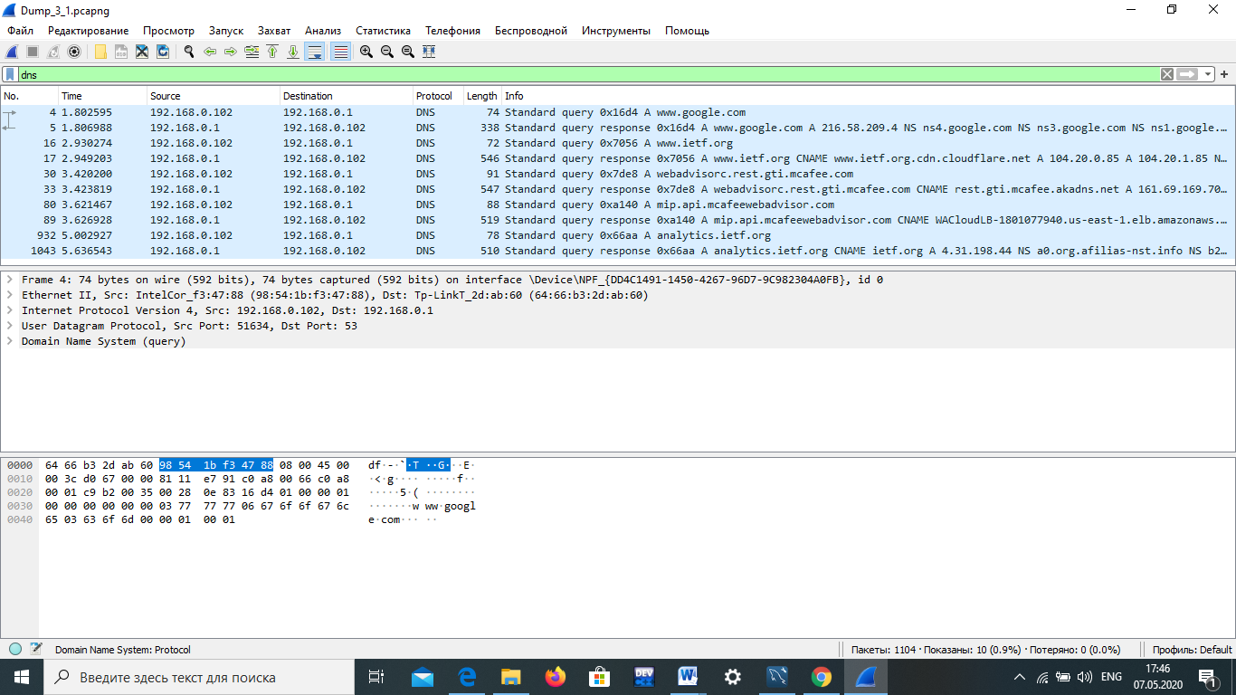

Цільовий порт: 53

Вихідний порт: 51634

1. На який адрес IP був відправлений запит DNS? Чи є цей адрес адресом локального сервера DNS?

IP:192.168.0.1, є адресом локального порта. 3.Проаналізуйте повідомлення із запитом DNS. Якого

«Типу» цей запит? Чи вміщує цей запит деякі можливі компоненти «відповіді»?

Цей запит – є запитом стандартного типу. Вміщує.

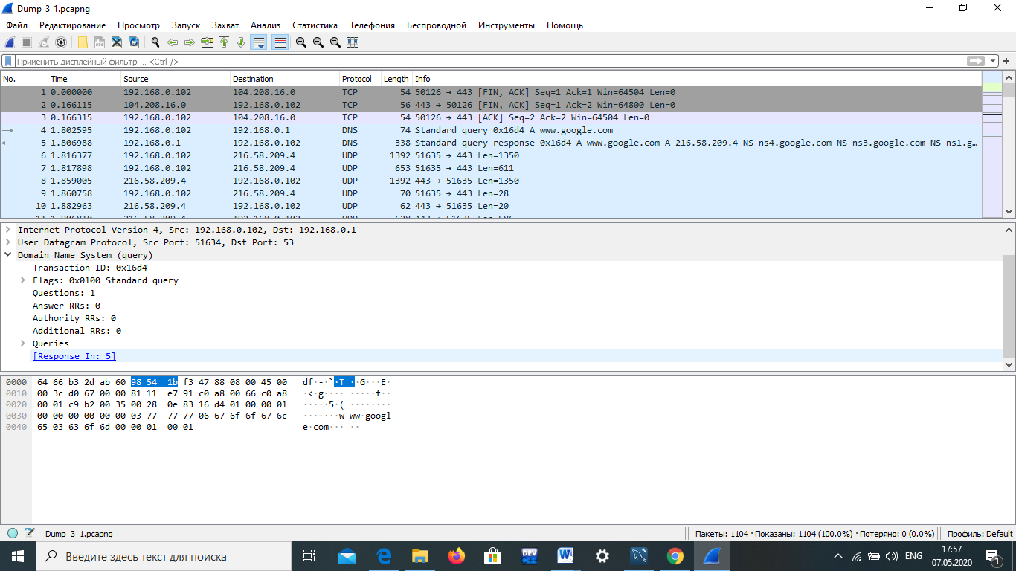

1. Дослідіть повідомлення із відповіддю DNS. Яка кількість відповідей запропонована сервером? Що вміщує кожна з цих відповідей?

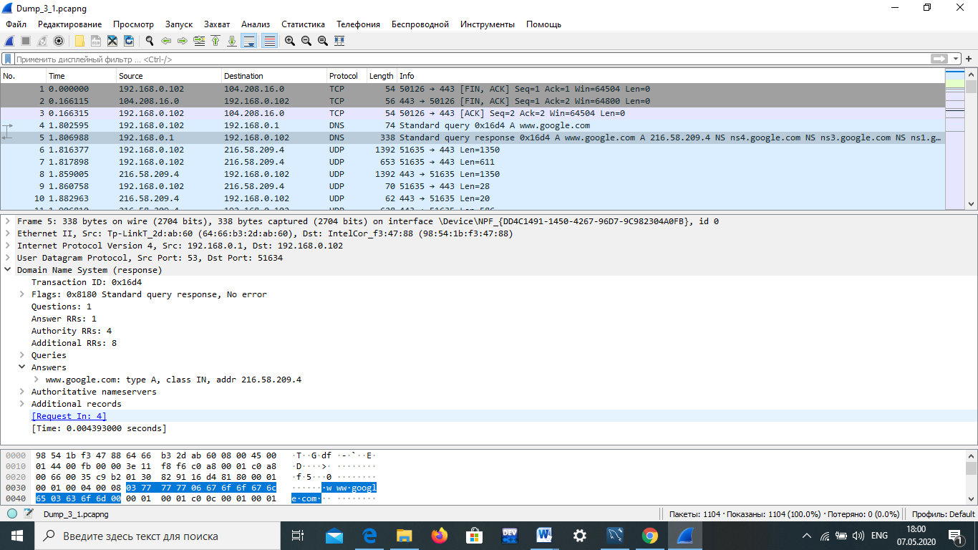

1. Проаналізуйте повідомлення TCP SYN, яке відправила ваша робоча станція після отримання відповіді сервера DNS. Чи співпадає цільова IP адреса цього повідомлення з одною із відповідей сервера DNS?

Так, співпадає

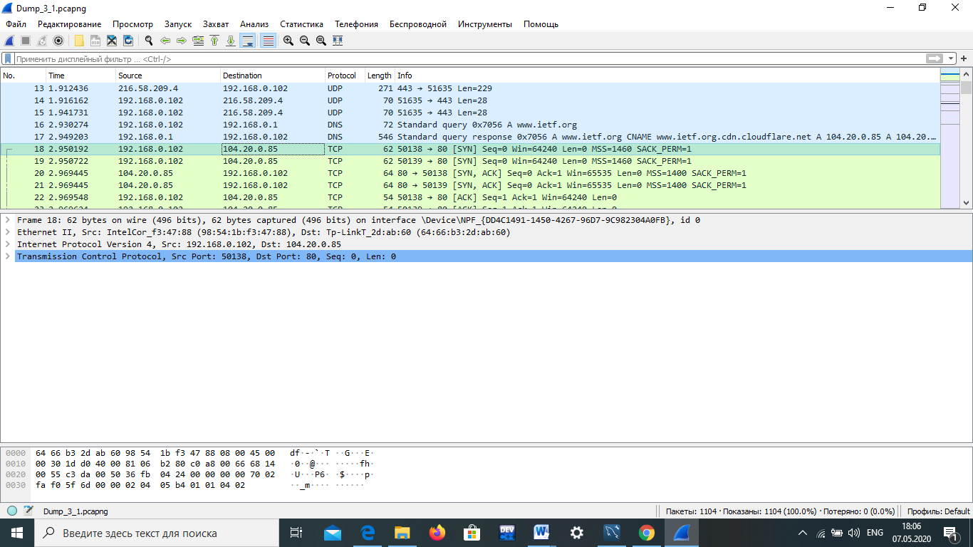

1. Чи виконує ваша робоча станція нові запити DNS для отримання ресурсів, які використовує документ, що отримав браузер?

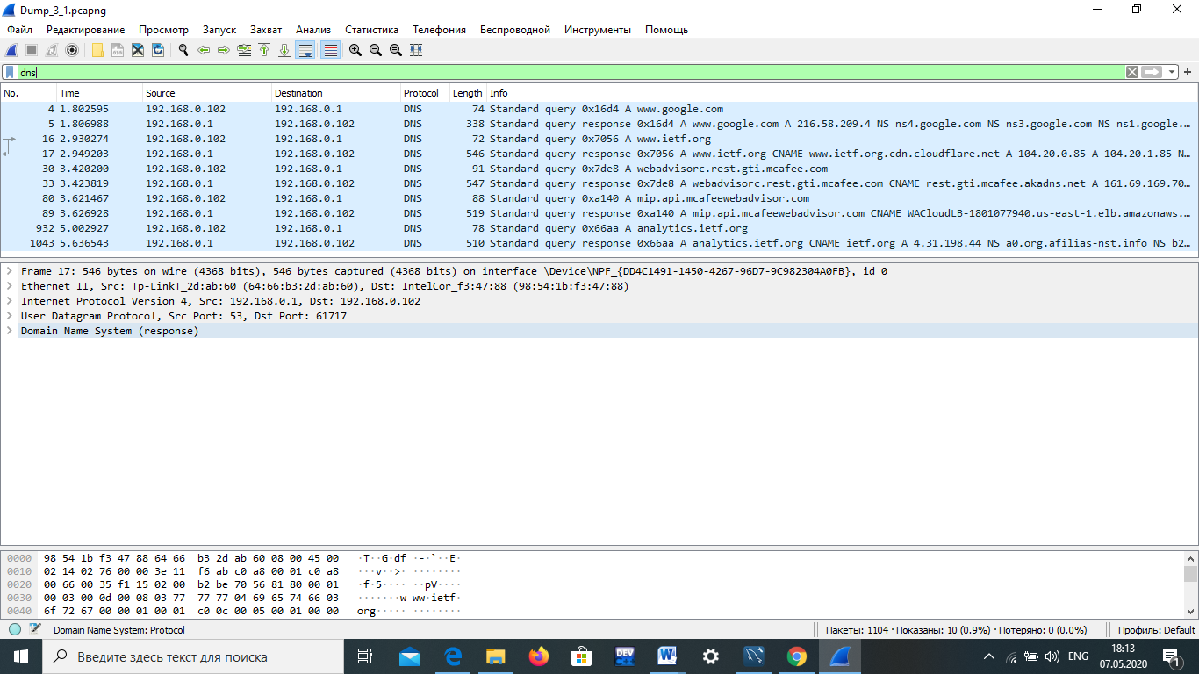

1. Яким був цільовий порт повідомлення із запитом DNS? Яким був вихідний порт повідомлення із відповіддю DNS?

Цільовий: 192.168.0.1

Вихідний: 192.168.0.1

1. На яку IP-адресу був направлений запит DNS? Чи є ця адреса адресою вашого локального сервера DNS за замовчанням?

192.168.0.1, є адресою локального сервера

1. Дослідіть повідомлення із запитом DNS. Якого

«типу» був цей запит? Чи вміщує цей запит деякі можливі компоненти «відповіді»?

Цей запит – є запитом стандартного типу. Вміщує.

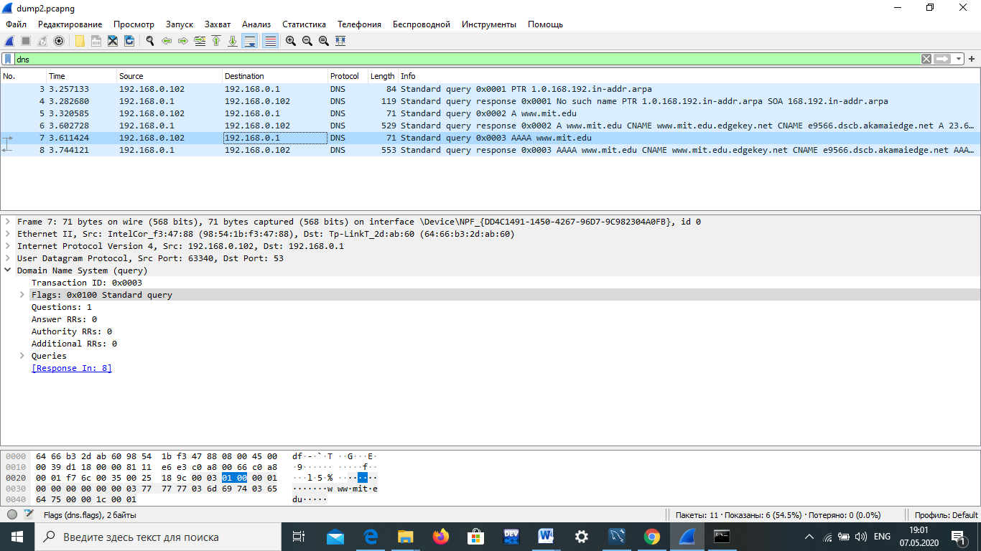

1. Дослідіть повідомлення із відповіддю DNS. Скільки записів із відповідями було запропоновано сервером? З чого складається кожна із цих відповідей?

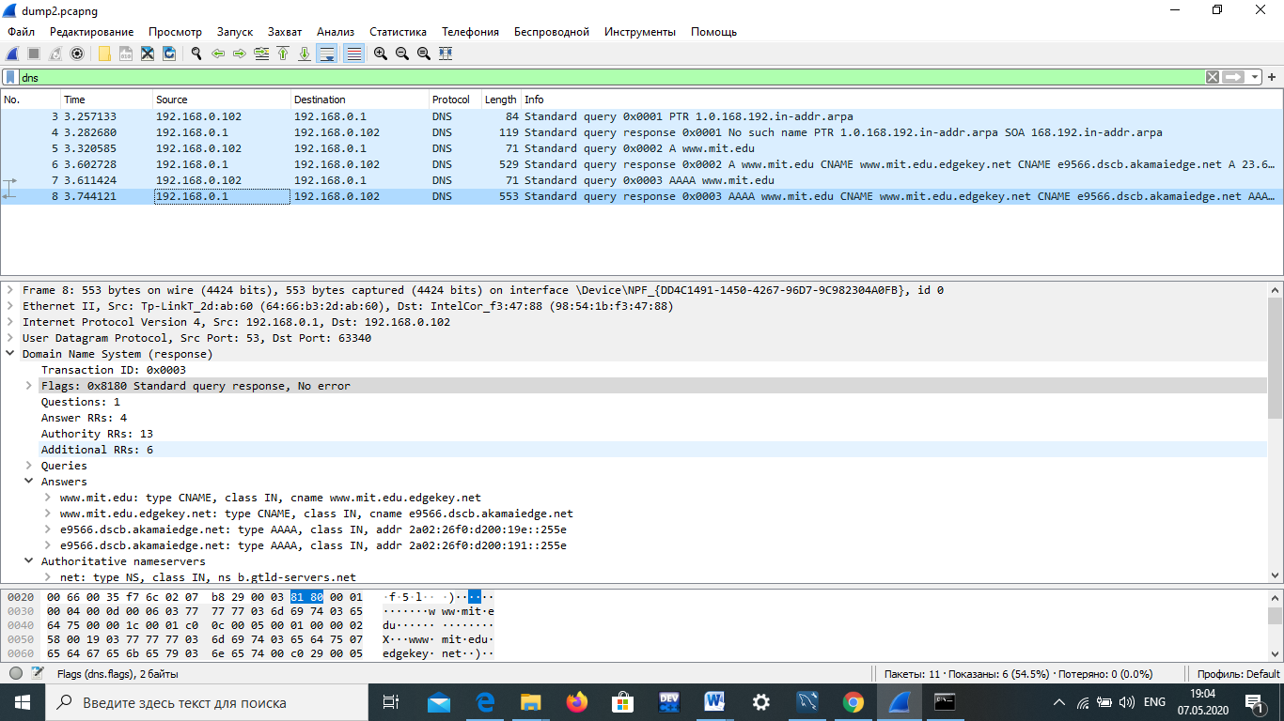

1. На яку IP-адресу був направлений запит DNS? Чи є ця адреса адресою вашого локального сервера DNS за замовчанням?

IP: 192.168.0.1. Так є.

1. Дослідіть повідомлення із запитом DNS. Якого

«типу» був цей запит? Чи вміщує цей запит деякі можливі компоненти «відповіді»?

Стандартний тип запиту. Так вміщує.

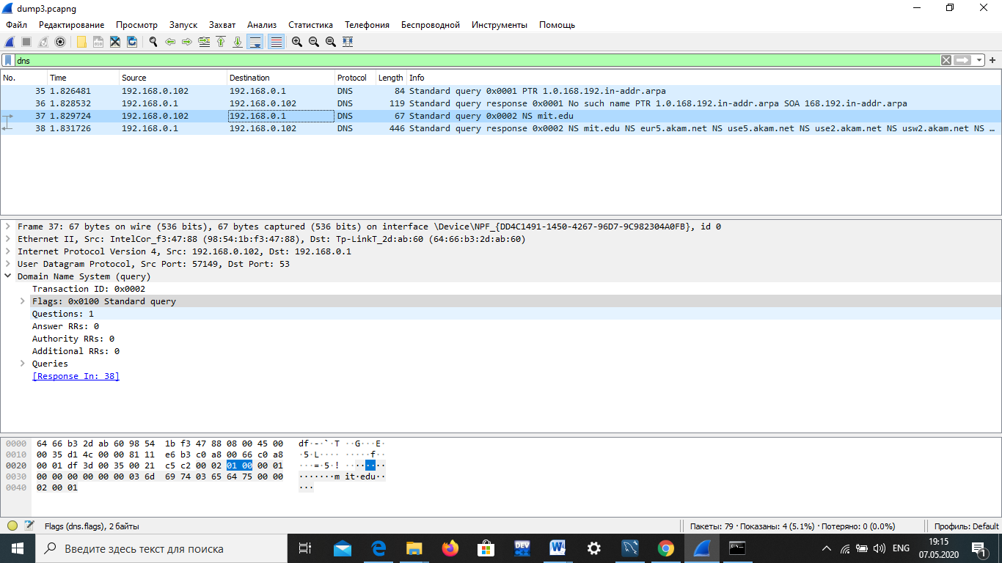

1. Дослідіть повідомлення із відповіддю DNS. Скільки

записів із відповідями було запропоновано сервером? Які сервери DNS були запропоновані у відповіді?

Сервери були запропоновані за допомогою доменного імені, адреси IP або й того й іншого?

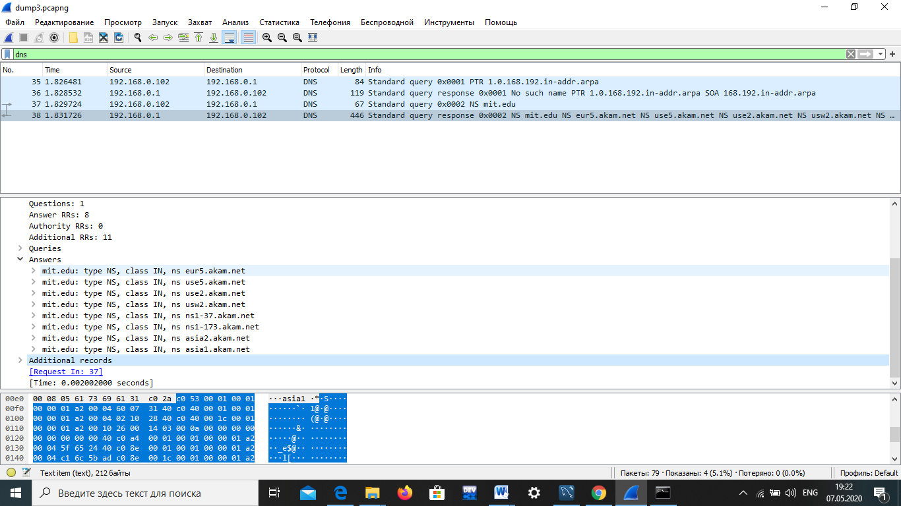

1. На яку IP-адресу був направлений запит DNS? Чи є ця адреса адресою вашого локального сервера DNS за замовчанням? Якщо ні, то якому доменному імені відповідає ця IP-адреса?

IP: 18.0.72.3. Не є адресою локального сервера.

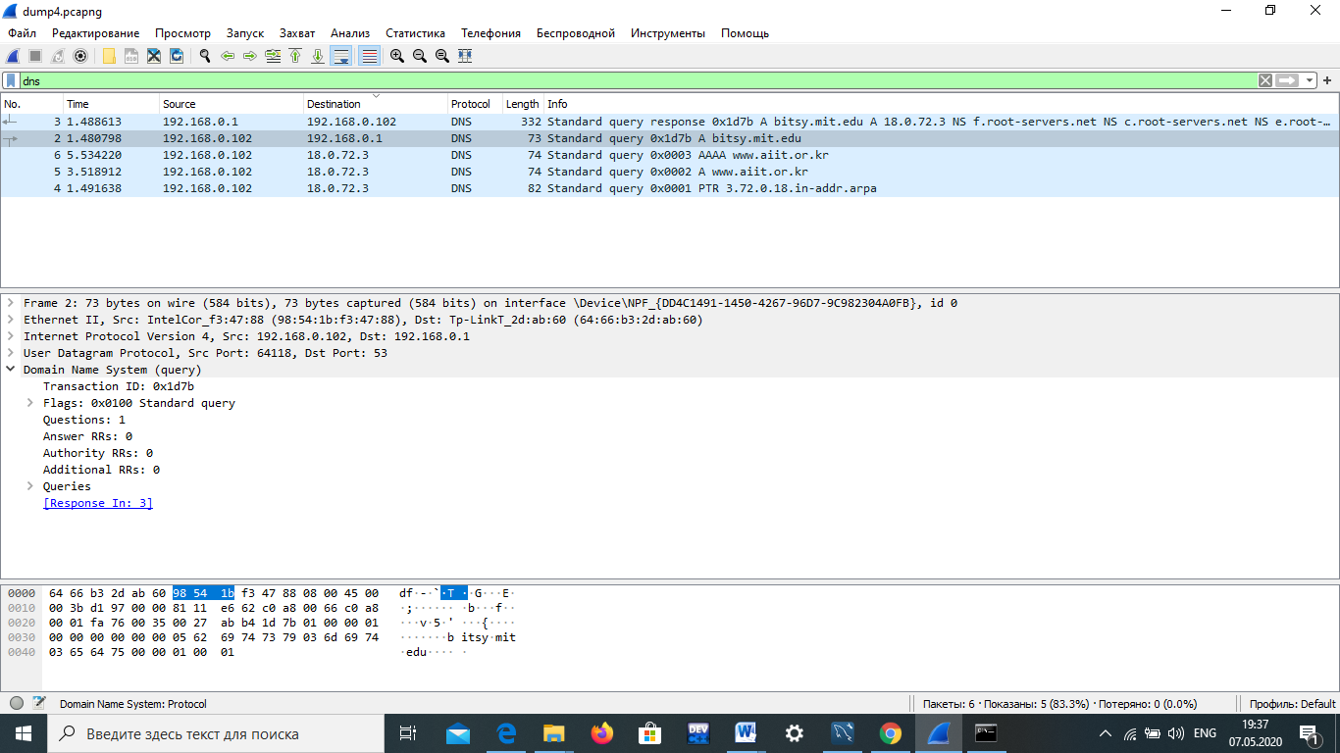

1. Дослідіть повідомлення із запитом DNS. Якого

«типу» був цей запит? Чи вміщує цей запит деякі можливі компоненти «відповіді»?

Стандартний тип запиту. Ні не вміщує.



1. Дослідіть повідомлення із відповіддю DNS. Скільки записів із відповідями було запропоновано сервером? З чого складається кожна з цих відповідей?

1 запис.

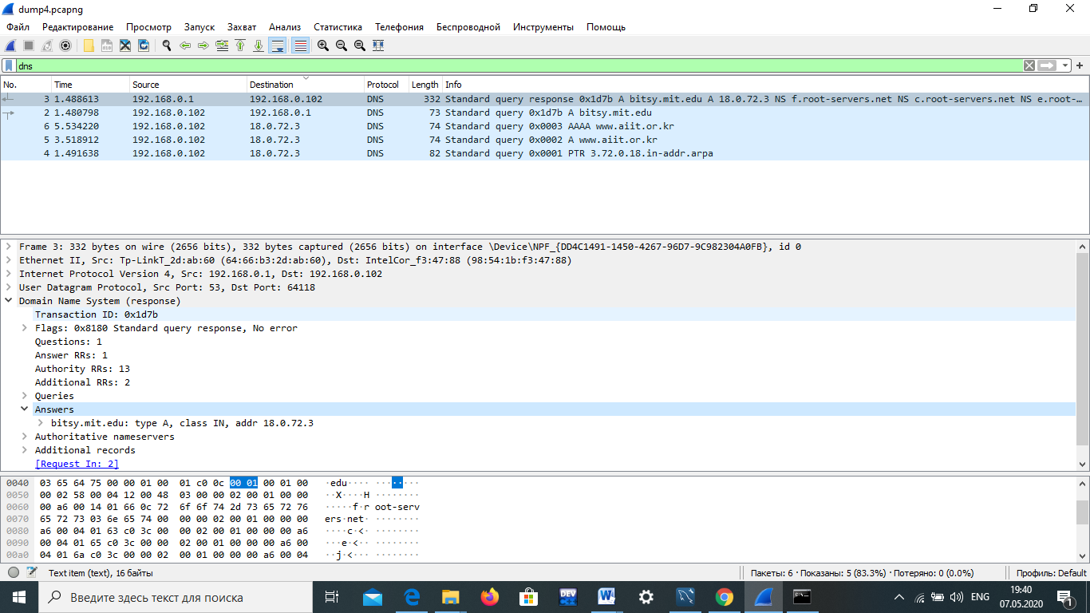

**Висновок:** В ході виконання даної лабораторної роботи, були покращені навички використання програми Wireshark для захоплення пакетів. Було проаналізовано протоколи DNS та було проведено аналіз деталей роботи даних протоколів.